**ENHANCED SOCIAL INTERACTIVITY LEVERAGED BY LOCAL PARTICIPANT DISCOVERY USING A CLOSE RANGE COMMUNICATION SYSTEM**

**ABSTRACT**

A method is described for enhancing social interactivity by discovering potential participants within a geographical locale using a close range communication system. Agents use a computer application, typically on a smart phone, to advertise identifying information to each other via a close range communication service, such as Bluetooth. A group of mutually identified agents can then form ad hoc communities of participants that interact in various social activities within the locale of the participants. Online interactions can be enhanced with the opportunity for personal interactions, leading to more satisfying social outcomes. Social activities might involve gaming, buying and selling, dating, and many more possibilities. Identities could also be authenticated, allowing trust-based transactions to take place.

**Inventors**:

Thomas E. Portegys, DeKalb, Illinois, USA ([portegys@gmail.com](mailto:portegys@gmail.com))

**CLAIMS**

1. A device, typically mobile, equipped a close range communication system that allows agents to identify and possibly directly communicate with each other in a local area that is within the range of the communicating system.
2. Together with the above, a centralized or distributed service accessible to the agents that allows them to form an ad hoc group to interact in various ways as participants in an enterprise of some sort. The service may take various forms. For example, gaming, buying and selling, and dating are possibilities.
3. The service may also embody an agent authentication capability that allows trust-based transactions, such as buying and selling to occur.

**BACKGROUND OF THE INVENTION**

*FIELD OF THE INVENTION*

*DESCRIPTION OF THE RELATED ART*

*REFERENCES*

**SUMMARY OF THE DISCLOSURE**

**BRIEF DESCRIPTION OF THE DRAWINGS**

**DETAILED DESCRIPTION**

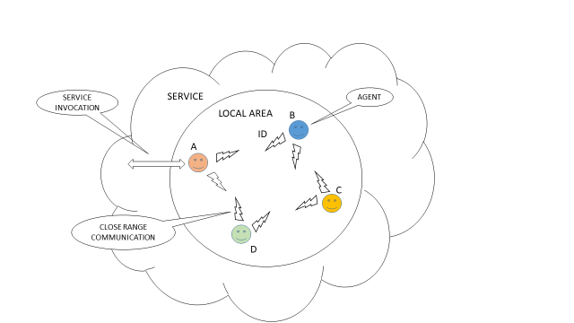

FIG. 1 – BASIC OPERATION